Our learning story begins with Michelle chatting with a group of children. She is explaining to them that today is the 1st of May and that means its May Day and she is going to make a may bush when she goes home.
She is speaking to a group of about 5 children and their response is to look at her with blank, perplexed expressions. Another teacher, Claire from Cork (where May Bushes are not well known), has a similar expression! She goes on to tell them that this morning she went out to the garden and washed her face with the dew from the grass to ensure eternal youthfulness! This this nothing to alleviate the confused and bewildered children and staff. Indeed Claire was sure that Michelle had lost all sense!
Michelle explains to all that we make a May Bush to celebrate the first day of May and the first day of Summer. Quite appropriately at this point, Anna points out that it is raining today and so not really summer! Lorraine points out to Anna that we can have all types of weather in May and that the weather man said it might be sunny later in the day.
Meanwhile Michelle is explaining to a steadily growing group of children that to make a May Bush we need to decorate a bush with ribbons and bright colours. The children’s facial expressions and body language at this point are showing obvious signs of interest and excitement. Anna says ‘let’s make a May Bush for Stepping Stones’. The other children respond with a chorus of yeses! Michelle explains again that we need a bush and some coloured paper or ribbon!
Jack McGuinness says’ I saw a bush outside that we could use’. Meanwhile Lorna and Ruby are investigating the arts and crafts cupboard, which is kept at the children’s level to ensure they have ongoing access to it, and report back that we have ‘loads of crepe paper that we can just cut up’.
The children go to take some crepe paper and scissors from the cupboard and begin to cut the crepe paper into strips. The children discuss among themselves the colours available and begin to choose the colours that they want to hang on the tree. It was a lovely opportunity to see the children expressing themselves creatively and experiencing the arts.
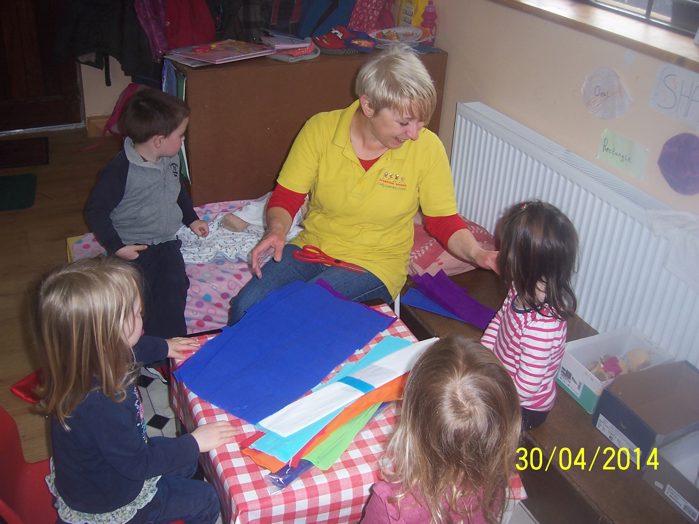

asdfasdf

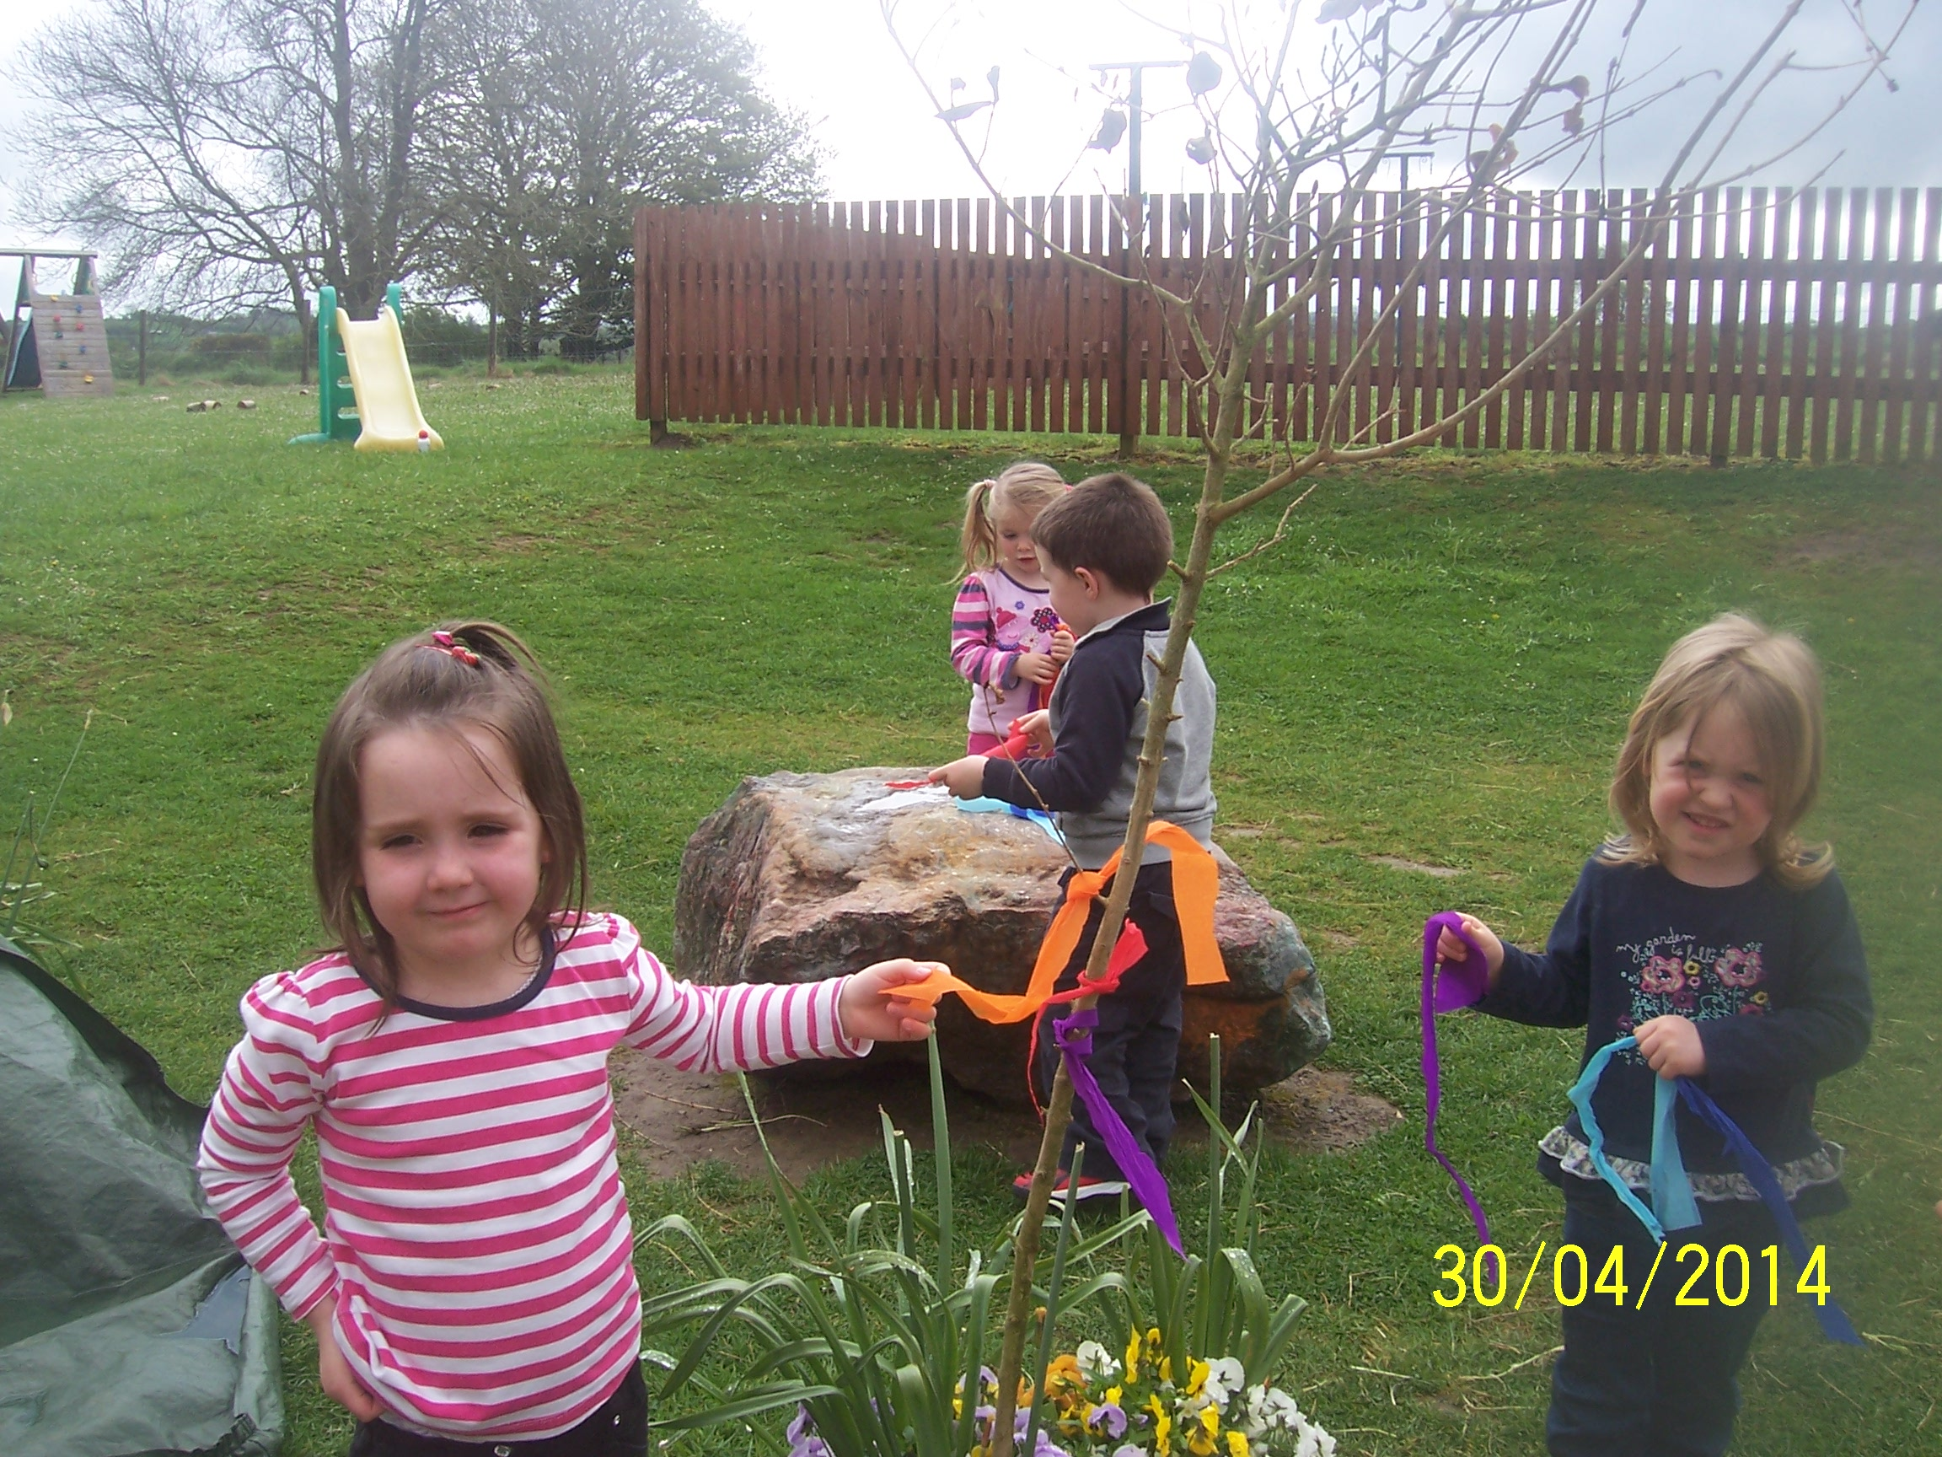

They children clearly expressed their views on what colours they would like to work with and Michelle acknowledged and supported these decisions without question. She then takes a group of children outside and they each chose the branch they want to tie their ribbon to. Some children ask the teacher for help which she does, and some of the other children spontaneously help the younger children. It was lovely to see the children confident in their own ability to do the task and also self assured enough to offer the younger children assistance.
Michelle then invites the children to wash their face in the garden dew! She explains again that this is to make sure that you can young and beautiful or handsome forever! Josh looks at her incredulously and states quite matter of factly ‘that’s mad!’ but continues to follow her lead and wash his face regardless. While this activity of washing one’s face from the grass is, generally, slightly unorthodox, we felt it a good opportunity to link in with a local tradition that is generally celebrated and acknowledged throughout our community.
When the children were happy that the May Bush was decorated to their satisfaction they were happy to return indoors. Some children wandered off to various activities around the room, while other children sat down and began to paint. The painting area is inside a set of double glass doors leading onto the garden area. The May Bush was directly outside the window and this inspired one of the teachers to paint a May Bush as she is sitting and chatting with the children. The other children, quite spontaneously, follow suit! The children take great care to choose their colours and ensure their bushes are colourful like the one outside. Some children went back and forth from the door to ensure they got a good likeness of the real bush!

It is suggested that we take down our springtime paintings and hang up our May Bush ones. Lorraine acknowledges that this is a very good idea and suggests she does this after the children go home.

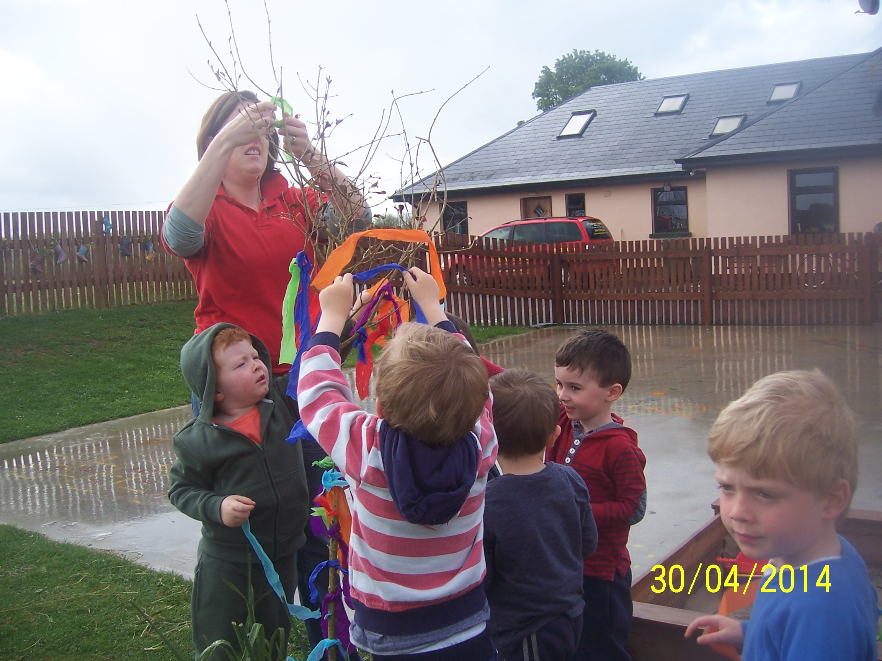

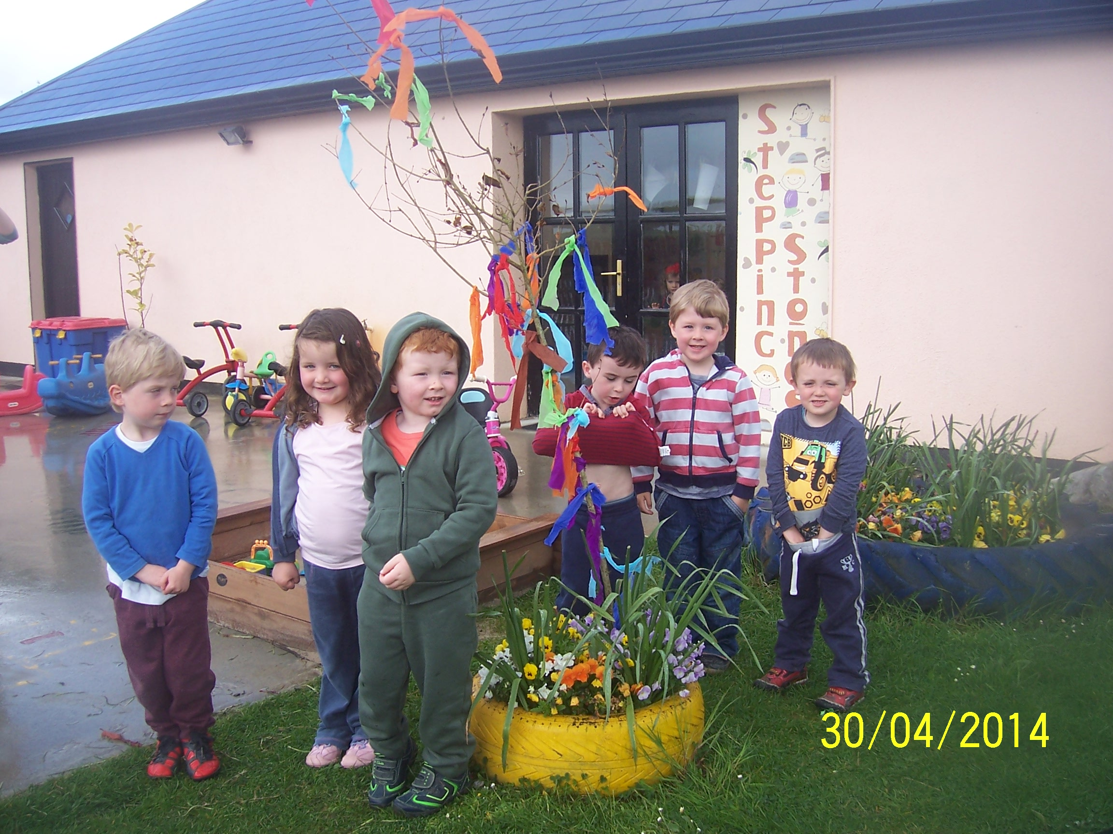

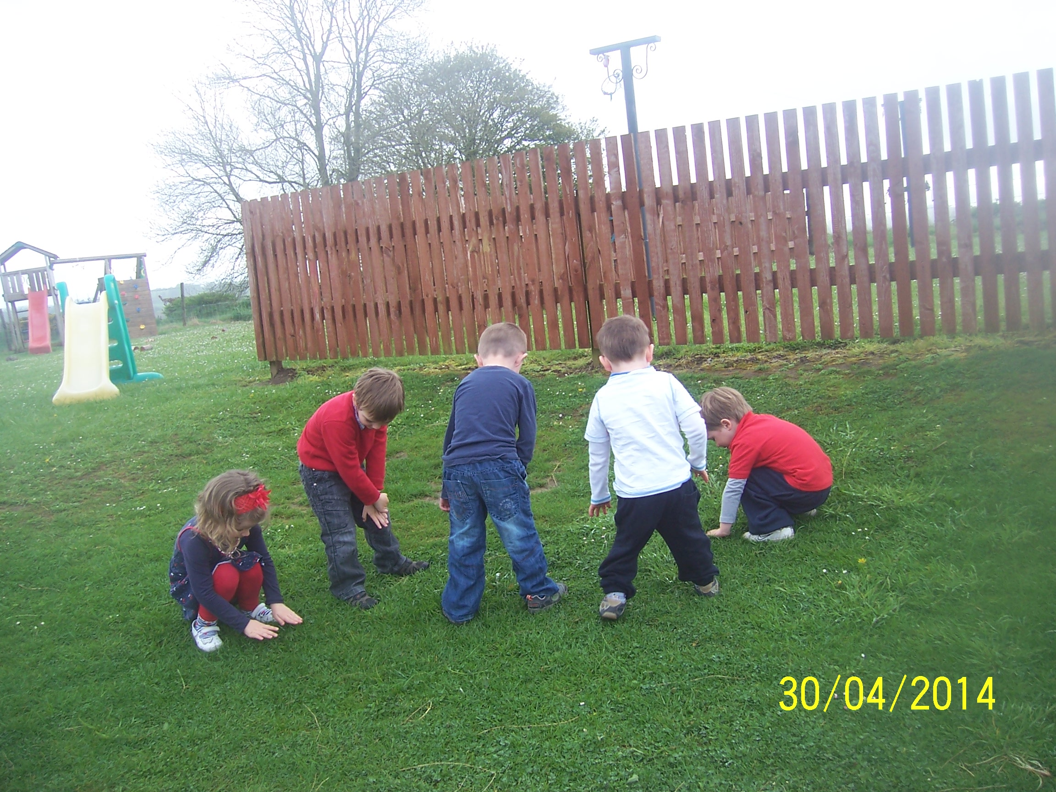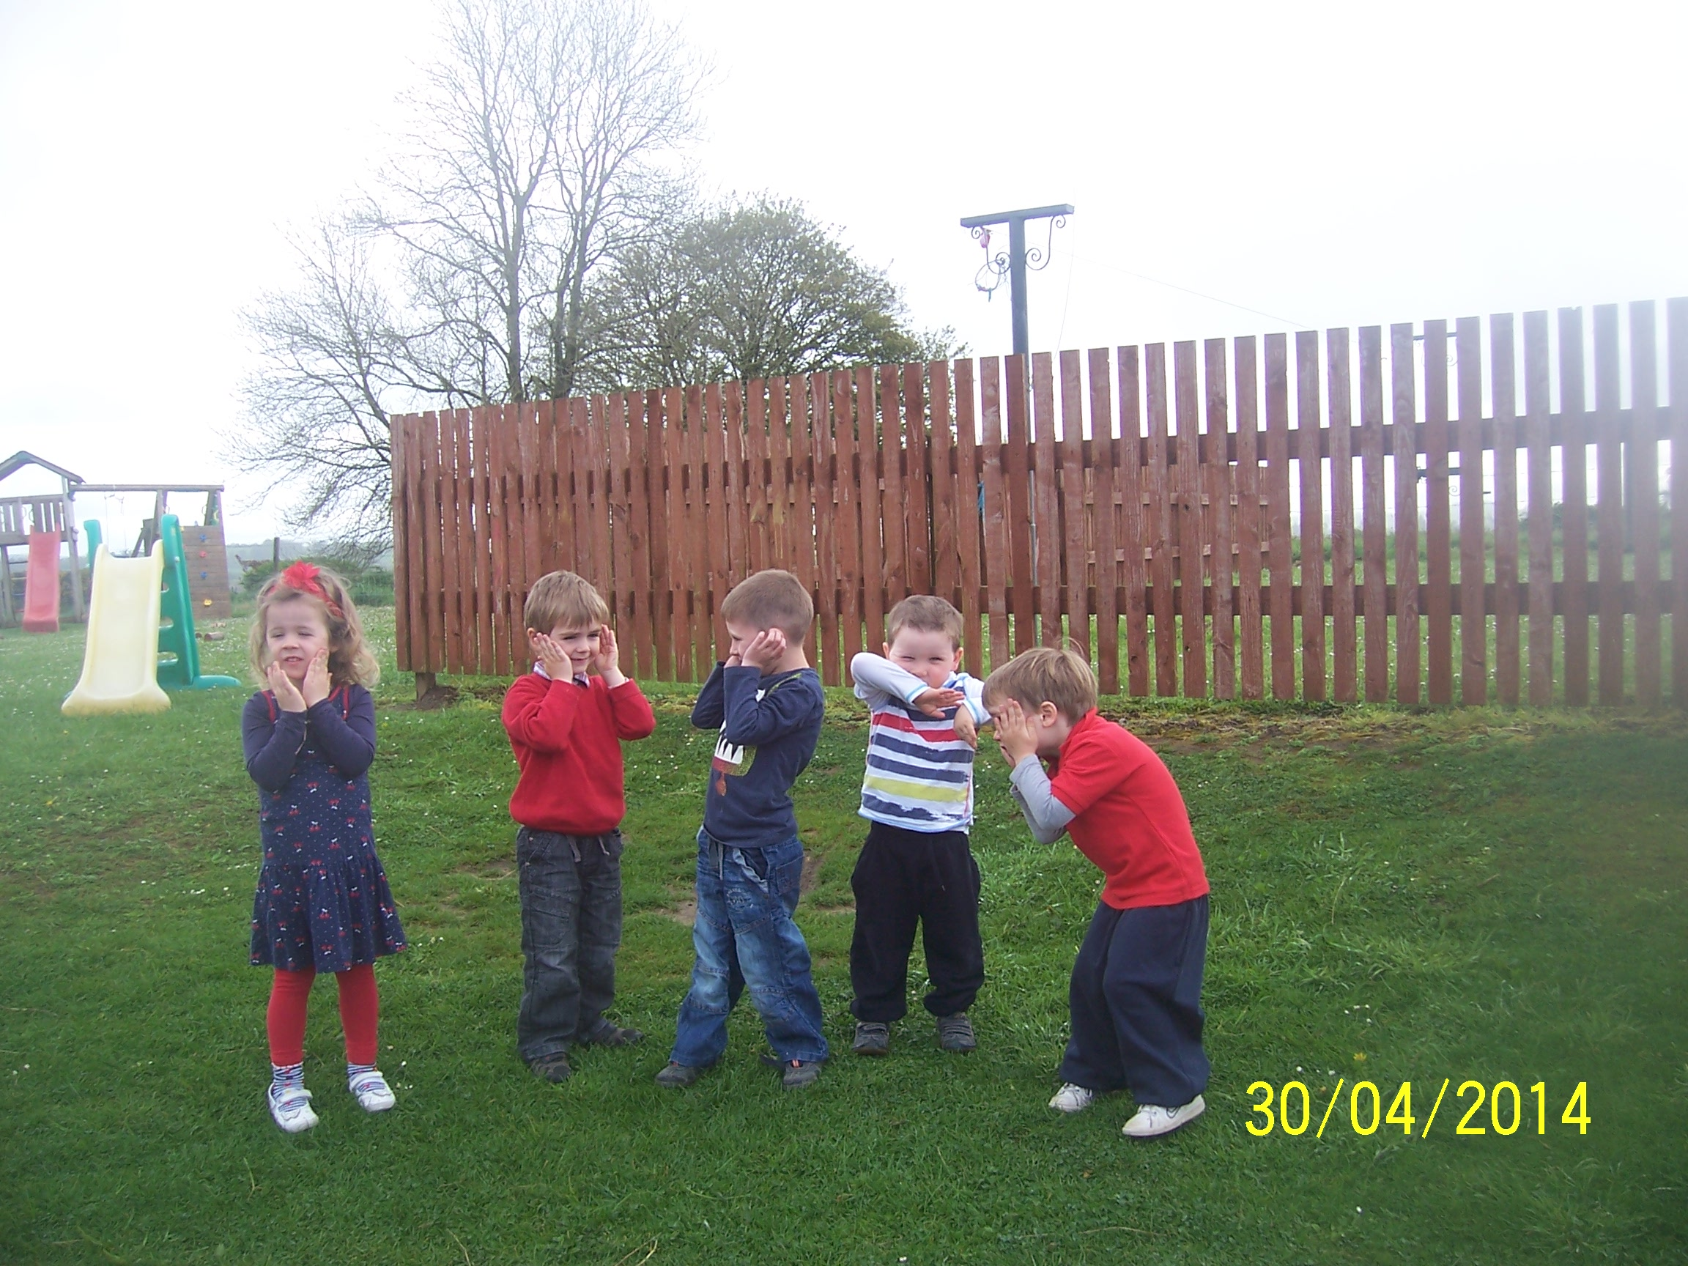
Samples of our paintings and some of the children’s comments –
Davin: ‘My Granddad knows everything and I am going to ask him to make a May Bush with me after school.’

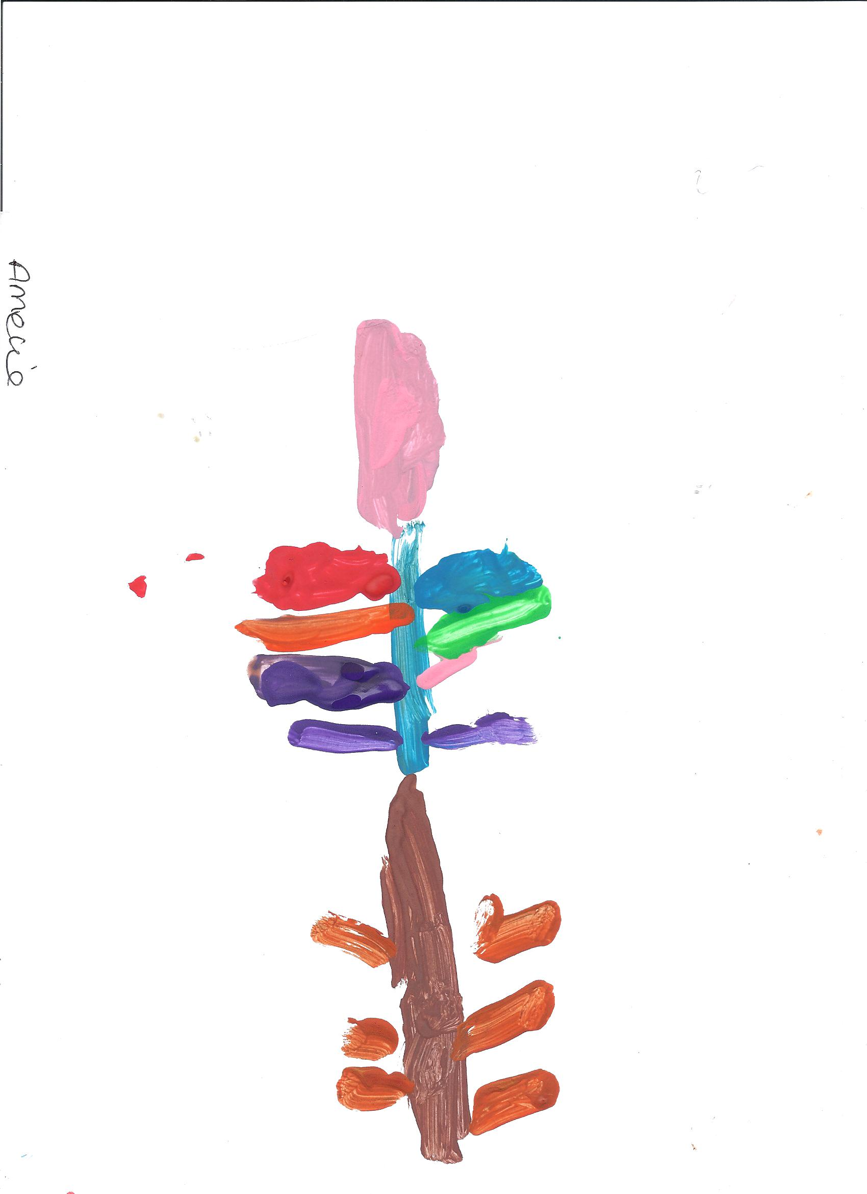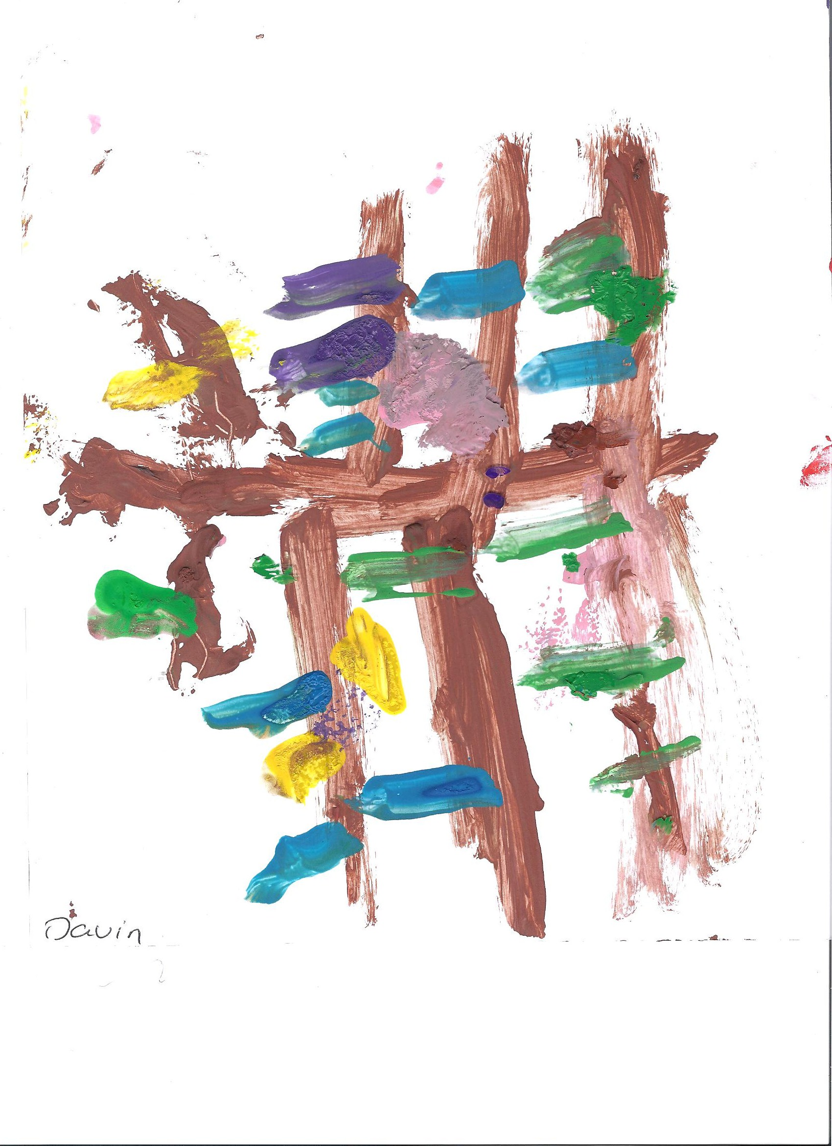

Amelie: ‘Look at how the ribbons on my painting flutter in the breeze, just like the ones on the bush outside’ as she blows her painting to help with the drying process
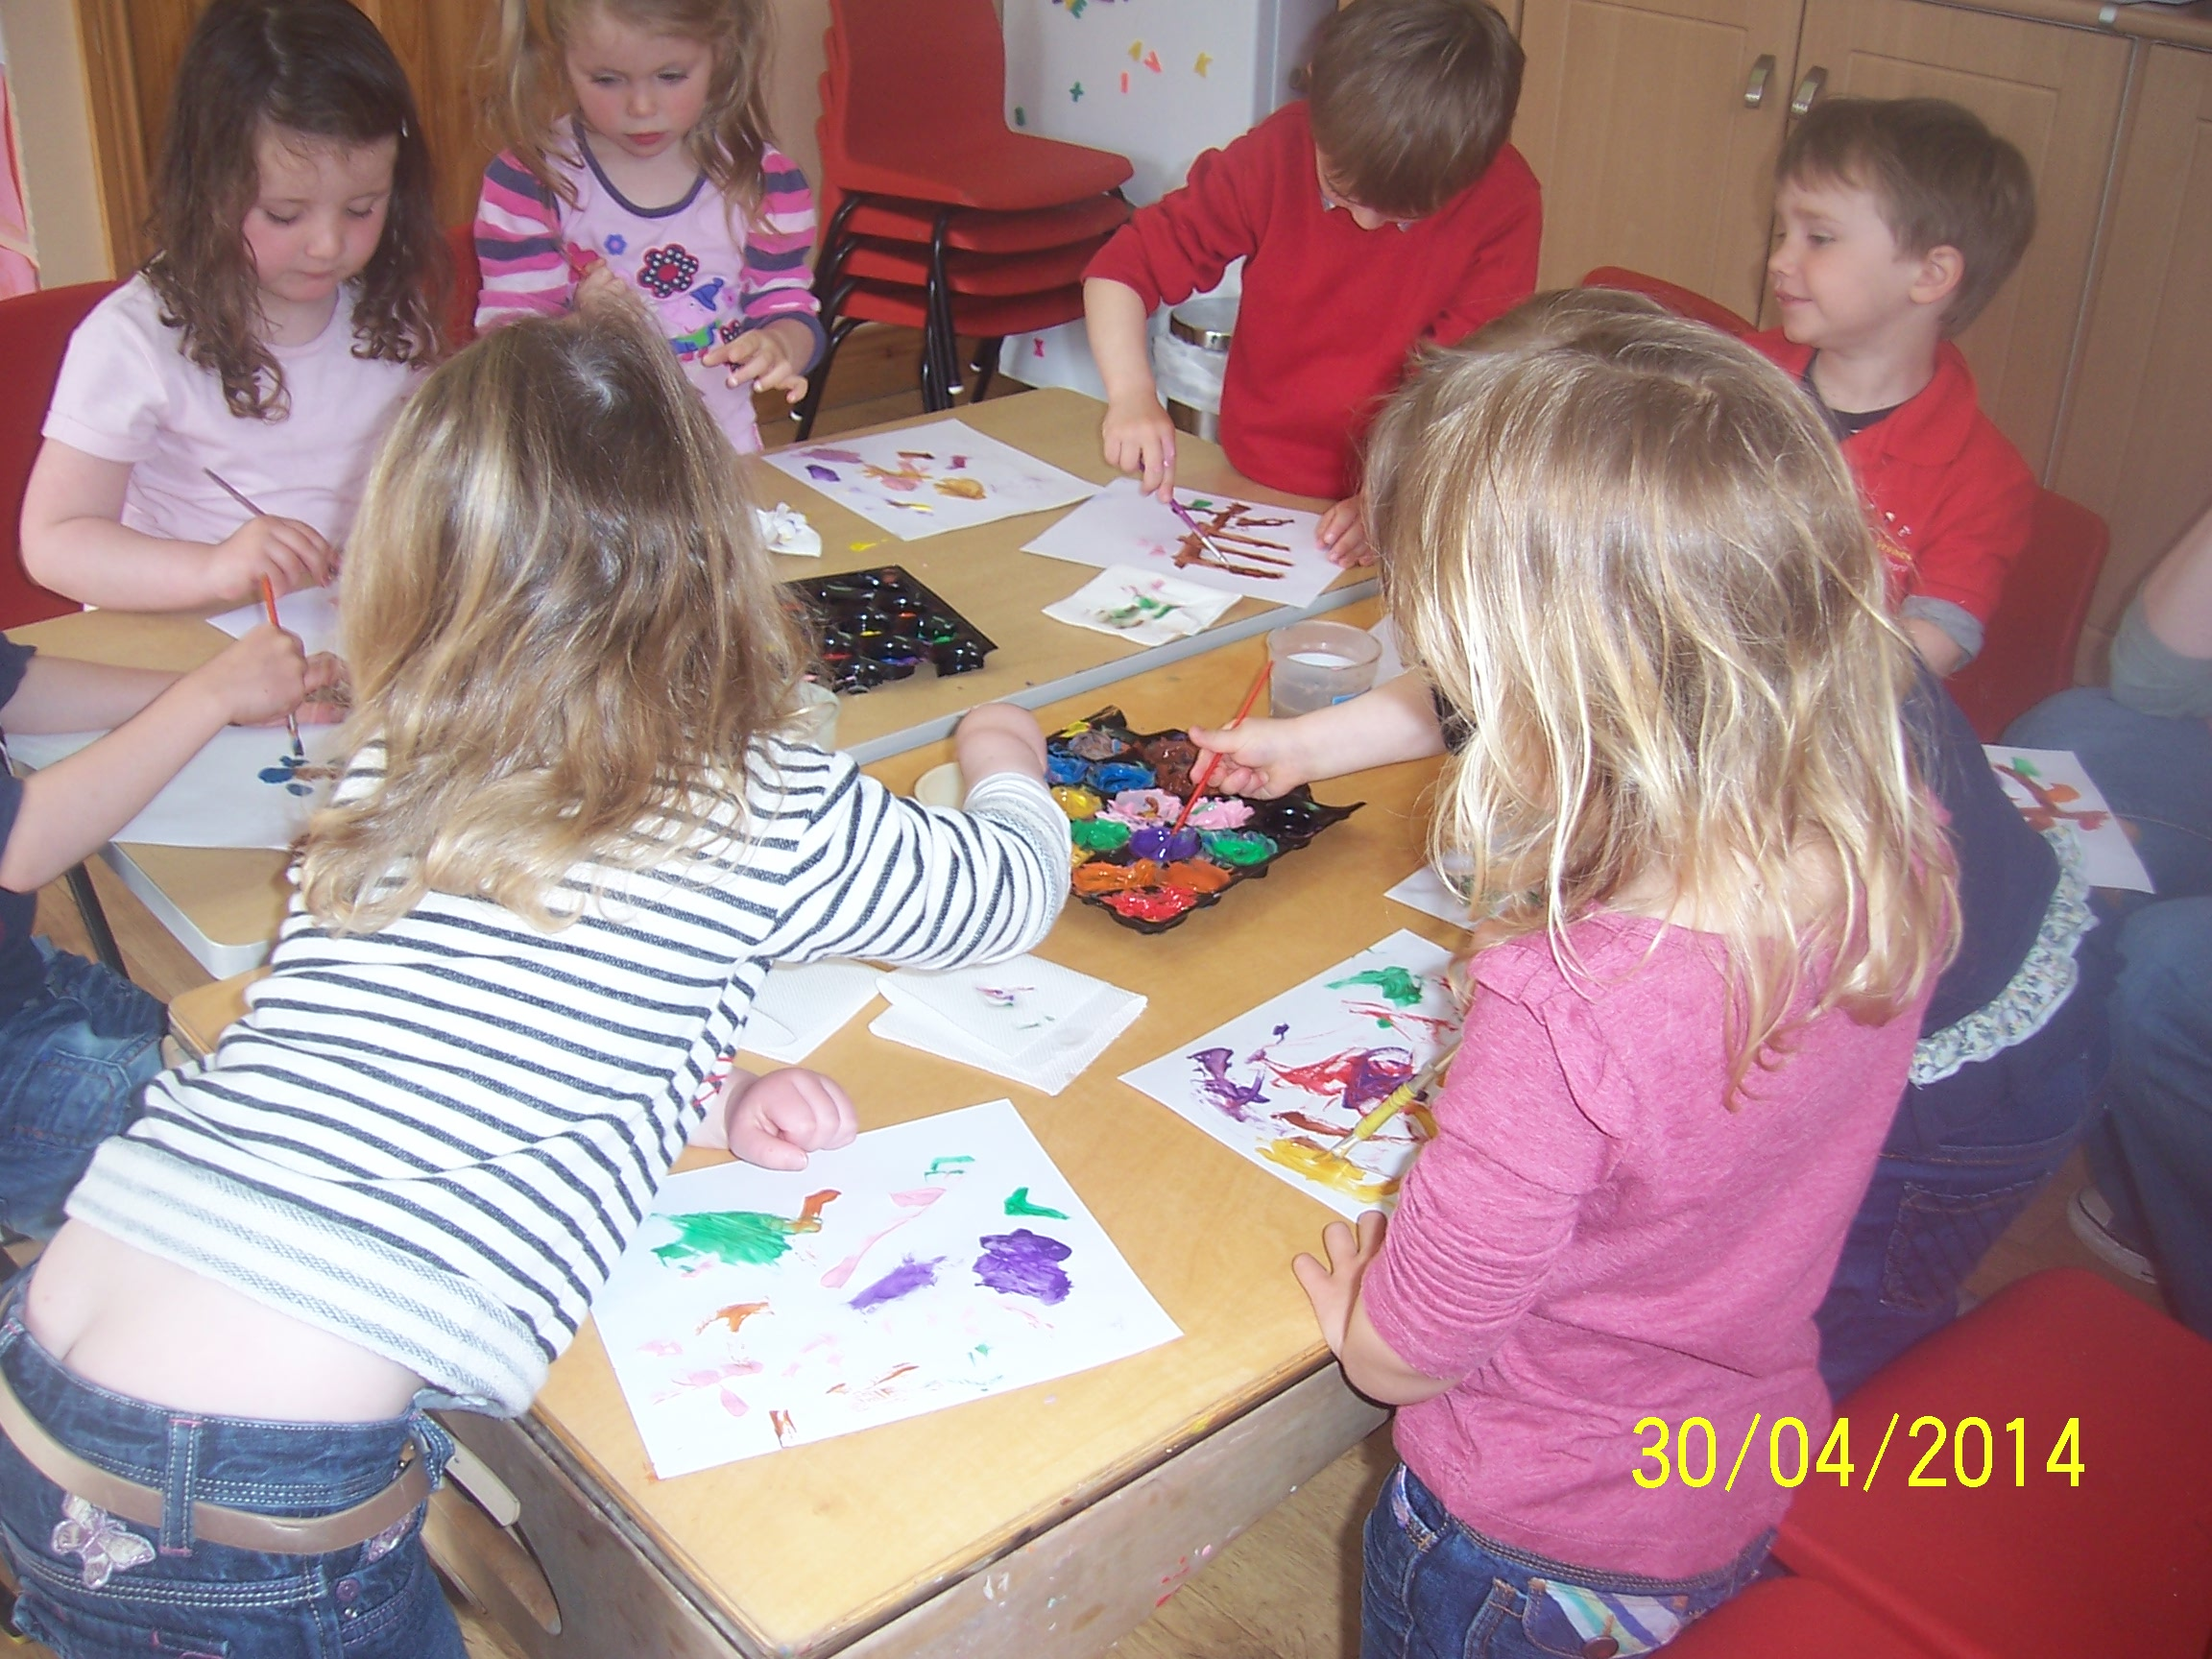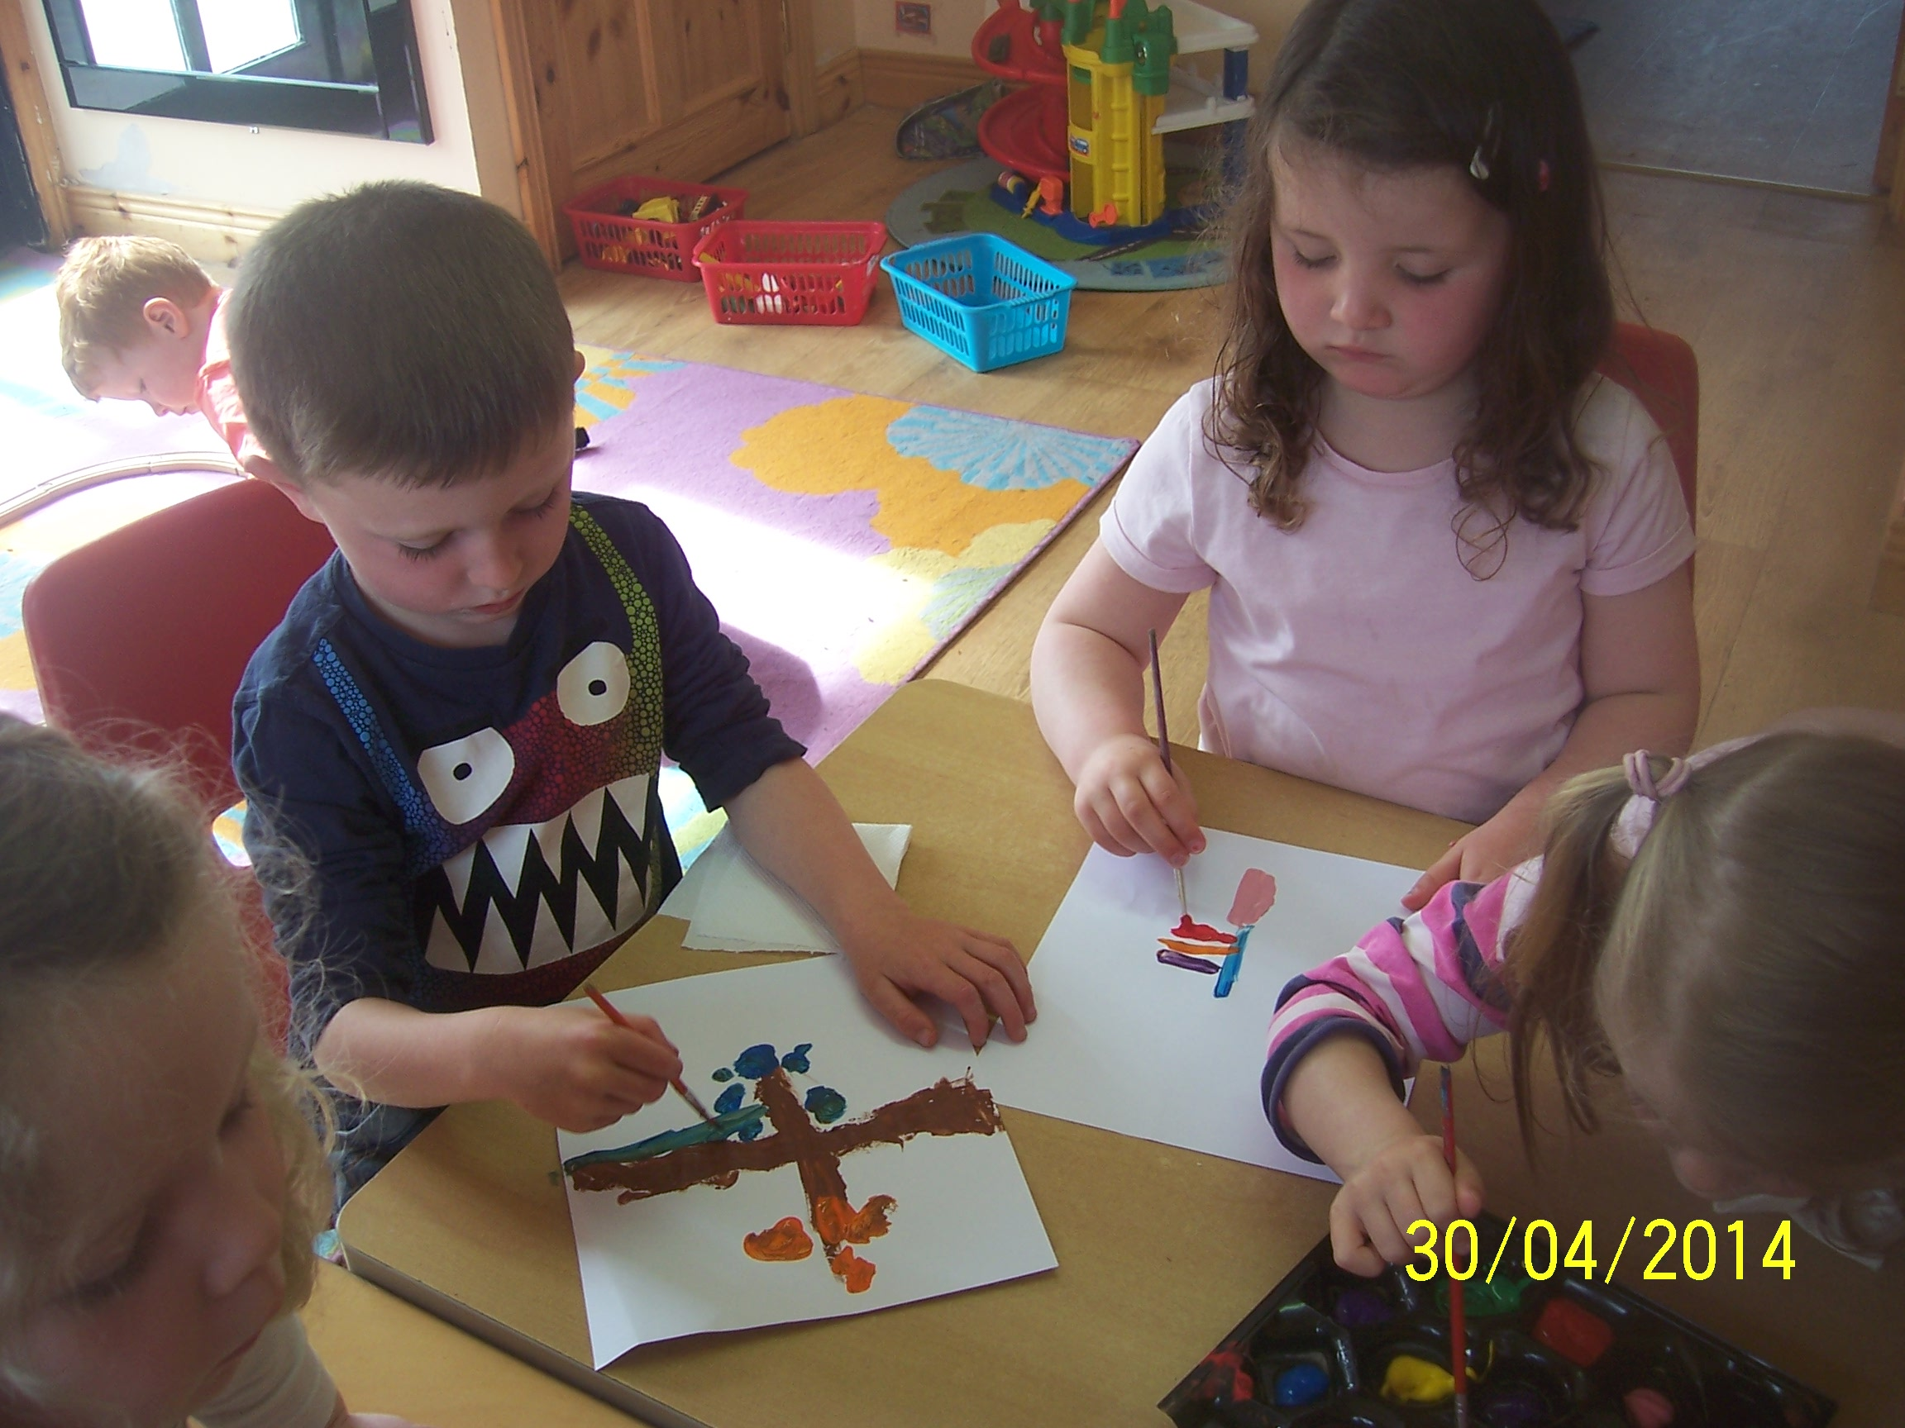

During group time that same day we are revisiting the various activities from the morning. There is a general consensus that the May Bush is a success and the children enjoyed completing it. We begin talking again about washing our face in the dew. This resulted in lots of laughing and Josh reiterating that it doesn’t make teachers look young and beautiful! Lorraine responded with a look of astonishment and amazement which in turn led to a lot of sheepish looks and mischievous giggling and tittering!
Amelie saved the day by telling us that we were already beautiful! She was soon joined by a chorus of young voices, some agreeing some arguing the point! It was a great opportunity to encourage the children to interact with other children and adults by listening, discussing and taking turns during group time.

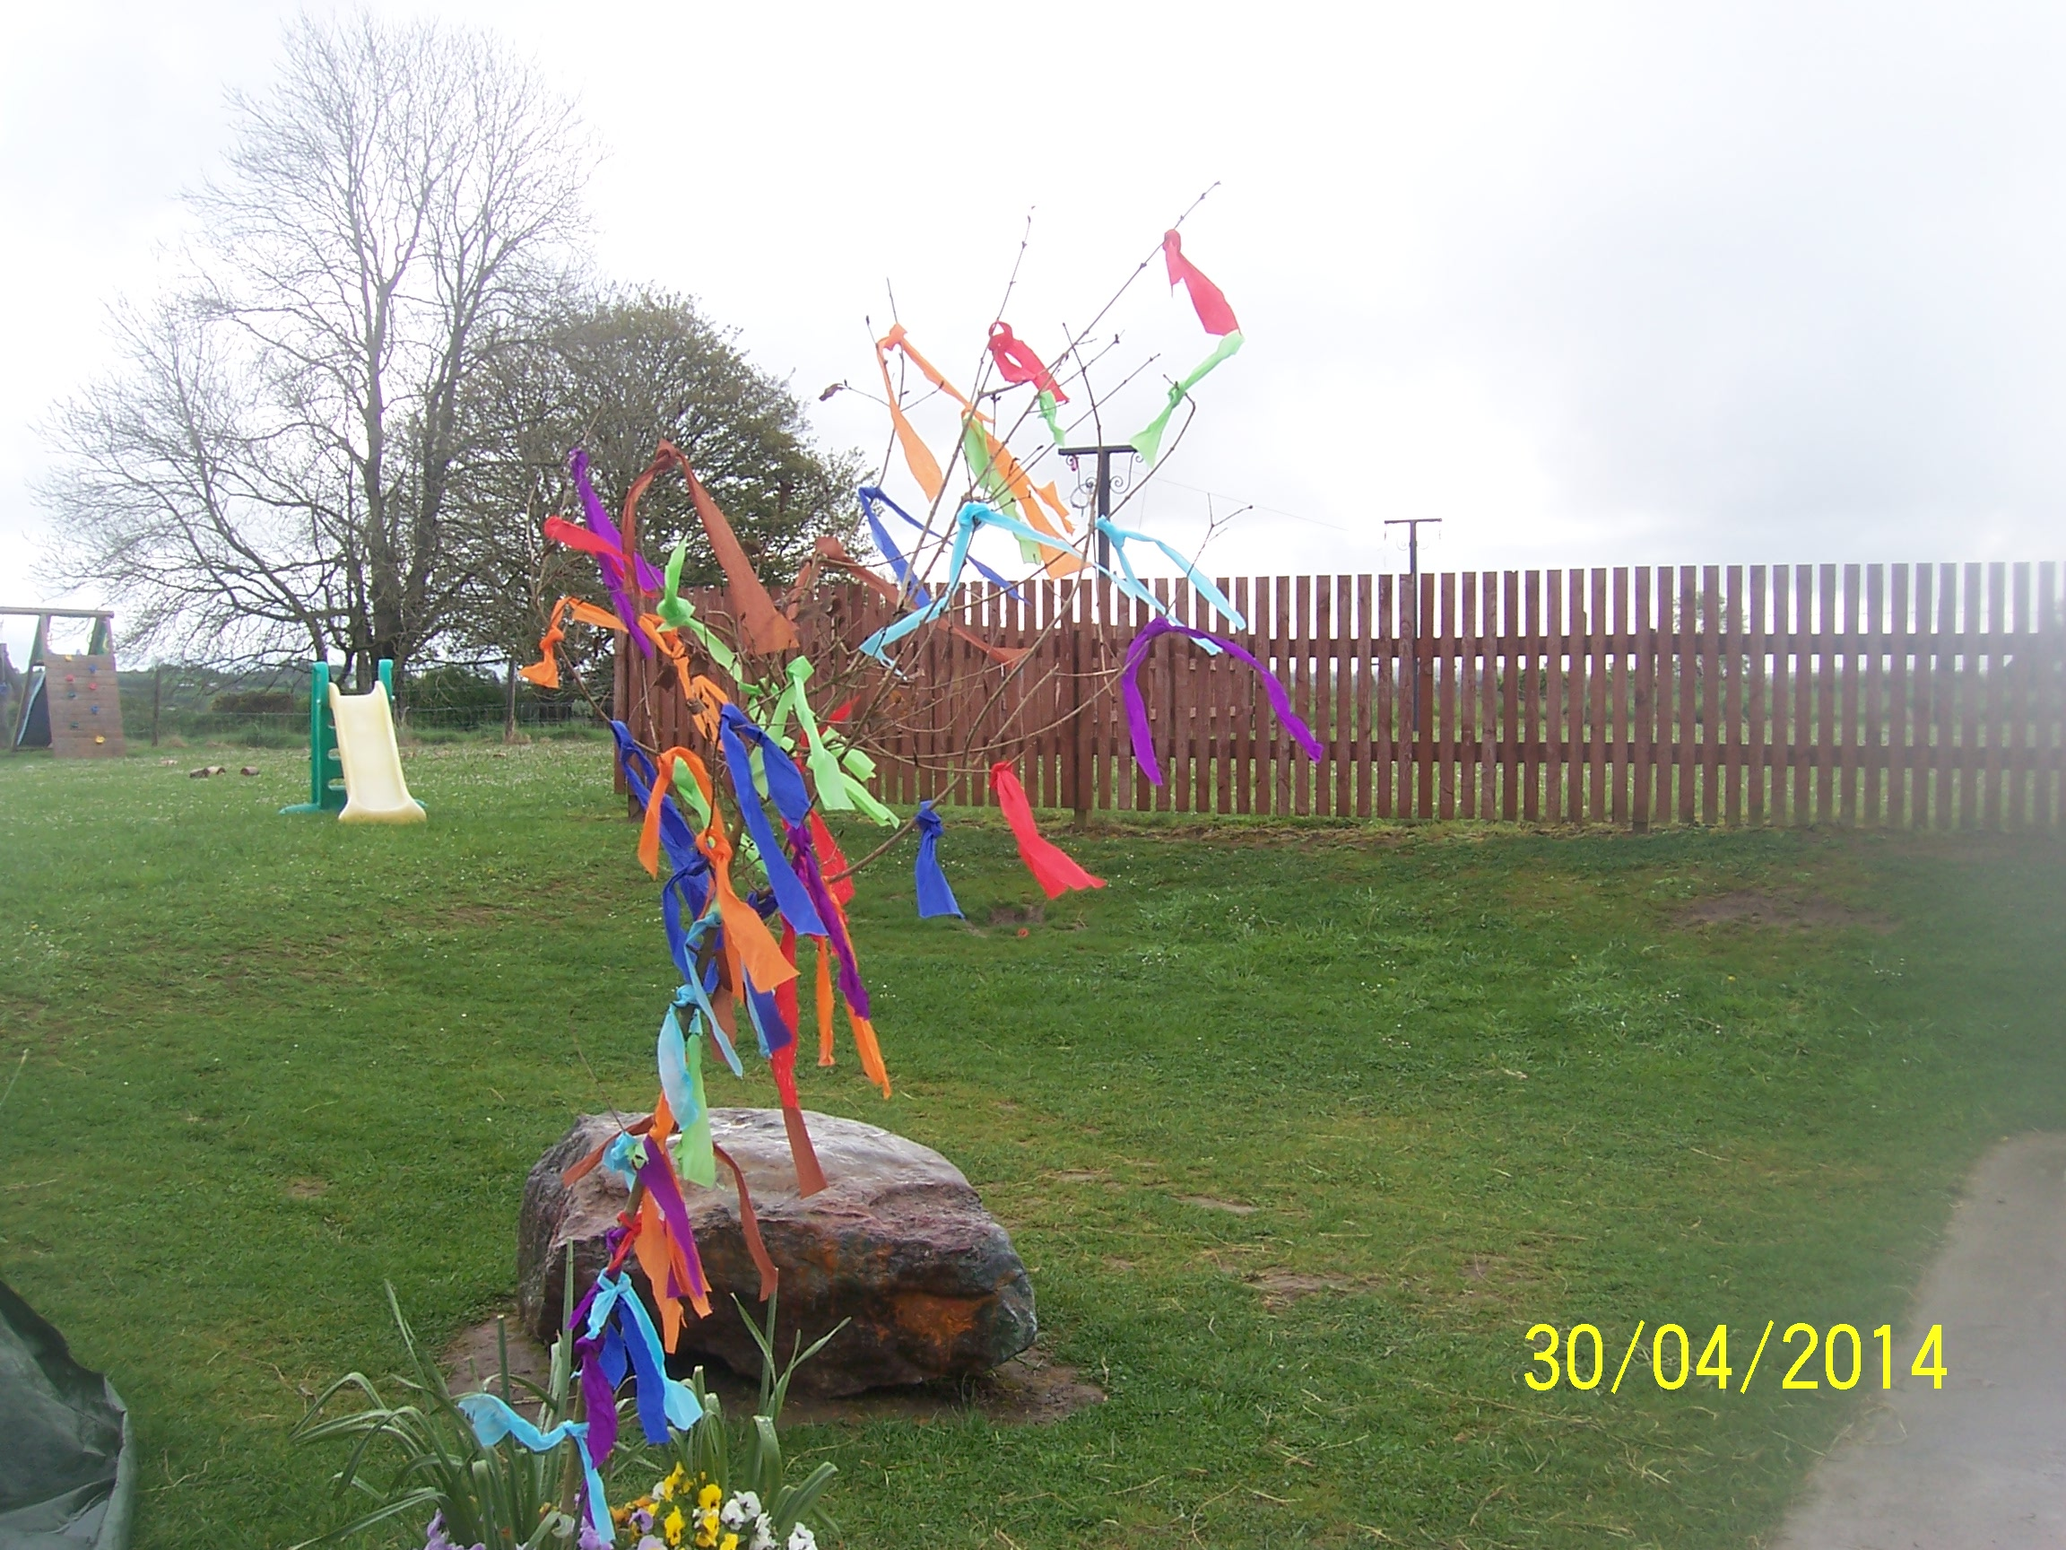

Upon collection of their children, many parents, commented on how lovely it was to see a May Bush. ‘I haven’t seen one of those in years’ said a parent in delight to Lorraine as she recalled making one with her mother and brothers and sisters when she was a ‘youngster’. Another parent said we had inspired her to go home to make one with all her children after school. This reinforced to us the importance of these daily informal chats with parents.

While this activity wasn’t in our curriculum plan for May – not surprising as our plan was completed by Claire who had never heard of a May Bush, before today! – but given how the story developed with Michelle that morning, and the children’s interest in the story, we thought that it was a good opportunity to expose the children to some Irish tradition and one that is very particular to the Midlands area.
In an article written by Jennie Lindon (Child Initiated Learning - http://www.teachingsolutions.com.au/samplepages/sp_Child_Init_Learn.pdf) she says -
“Effective early years educators understand the difference (between teacher led and child initiated activities) and, within a suitably flexible day, there will not be a firm division between child initiated and adult-led, but rather a flexible to and- fro. The educator provides a balance between child-led, child-initiated and educator supported learning and recognises spontaneous teachable moments as they occur, using them to build on children’s learning”
In Stepping Stones we are entirely committed to a broad-based, documented and flexible (Síolta, Standard 7, 2006) curriculum and this is evidence of why this is so important. In addition to supporting and implementing an emergent curriculum we also ensure that children understand and take part in routines, customs, festivals and celebrations.
The May Bush is often associated with luck for the house or community it was erected in. Hopefully this May Bush will bring us luck in our Learning Story Submission.
NOTE: The date was set wrong on our camera and was a day behind the rest of the world.

